Promotion of the “love of tennis” through friendliness. Bevordering van die “liefde vir tennis” deur vriendelikheid
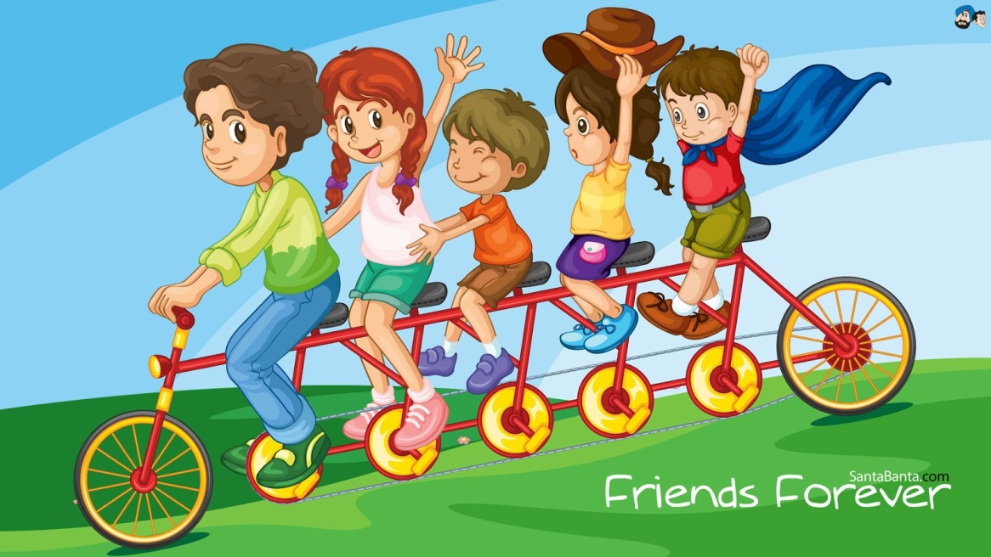

Definition: Going to trouble
to get to know your opponent
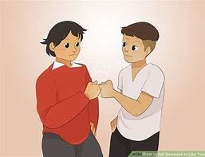
to get to like them. Om moeite te doen om jou opponent te leer ken om van hulle te hou.

Example: At the start of a match

Introduce yourself (your name & their name) and
shake the hand of your opponent. Voor die wedstryd stel jouself bekend aan die opponent en skud hul hand.
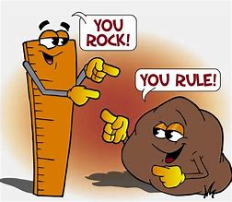
If there is anything you like about
what your opponent looks like, tell them
(racquet, tackies, clothes, hair). As jy iets sien waarvan jy hou van hoe die opponent lyk, vertel hul (raket, tekkies, kleure, hare)
Ask them where they go to school? Vra hulle na watter skool hul gaan?
If they like anything about you, say thank you enthusiatically. As hulle iets mooi sê van jou sê dankie.
Practical
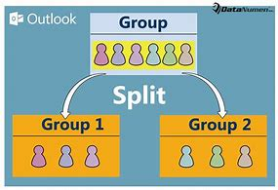
Split up in groups of two
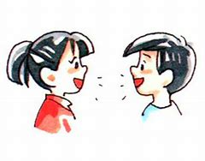
(separate into groups of first language speakers)
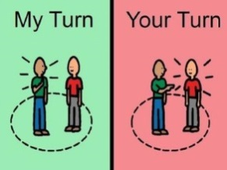
Take turns to introduce yourself first. Neem beurte om jouself eerste voor te stel.
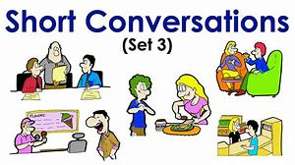
Keep the conversation short.
All you are trying to say is:
you are looking forward to playing against the opponent.
Hou jou geselskap kort. Basies probeer jy sê dat jy uitsien om met jou opponent te speel.
What is not friendliness in tennis? Verduideliking om vir jou te wat vriendelikheid nie is nie.
No talking between points. Jy mag nie tussen punte praat nie.
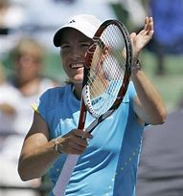
If you compliment an opponent after they played a point well,
rather make a clapping gesture on your racquet.
(Speaking during the match can put your opponent off).
Die manier om jou opponent te komplementeer is hom te wys dat jy op jou raket se snare klap as hul ‘n goeie wen hou speel. (Let op dat as jy praat in die wedstryd kan jy jou opponent afsit)

Why do you want an opponent enjoy playing against you? Wat is die redes hoekom jy wil hê jou opponent geniet dit om teen jou te speel?
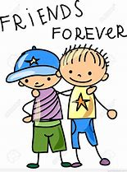
- They might become your friend in future. Hul mag jou vriend word.
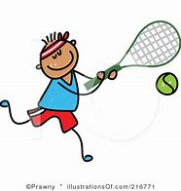
- You enjoy the match more yourself. Jy sal die wedstryd self meer geniet.
- It does not affect the result of whether you lose or win a match. Wat baie belangrik is die feit dat jy vriendelik is met jou opponent affekteer nie die uitslag van die wedstryd nie.

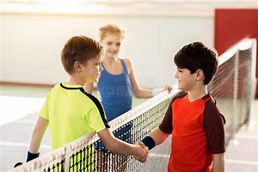
How do you end a match? Shake hands at the net.
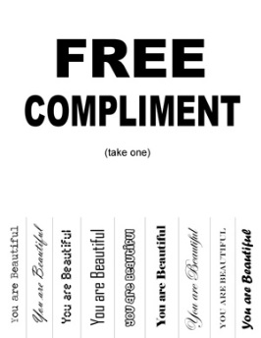
If you have won, try to genuinely compliment the opponent e.g. As jy gewen het probeer iets mooi sê van jou opponent b.v.
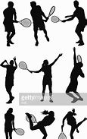
Any shots the opponent plays well
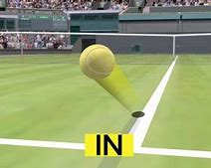
Any element of tennis etiquette (honest line calls) Enige element van tennis etiket (eerlike lyn roepe)
Their tennis equipment
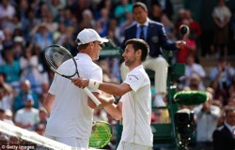
If you have lost, try to genuinely compliment the opponent e.g.
Any shots the opponent plays well
Sê vir hulle dat hul die beter speler was op die dag omdat (probeer identifiseer wat het veroorsaak da thy gewen het)
Offer to buy them a cold drink after the match. If you don’t have enough money tell them you would have liked to buy them a cold drink but you don’t have the money. Bied aan om hul ‘n koeldrank te koop na die wedstryd. As jy nie genoeg geld het nie se vir hom jy sou hom ‘n koeldrank gekoop het as jy die geld gehad het.

How you must view winning and losing Hoe om wen en verloor te ervaar
You must enjoy winning or losing equally.
In fact if you lose you must be happy for your opponent. If you win feel sorry (sympathise) for your opponent. Jy moet wen of verloor dieselfde geniet. As jy verloor moet jy gelukkig voel vir jou opponent. As jy wen voel jammer vir jou opponent.

Conclusion Gevolgtrekking
Although this is controversial
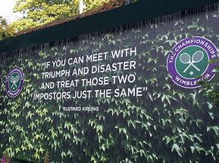
there is a plaque above the exit above Wimbledon main court that says
you must treat winning and losing equally. Alhoewel die laaste punt kontraversieel was se die bord bokant die Wimbledon hoofbaan uitgang van die hoofbaan dat deelnemers wen en verloor dieselfde moet hanteer.

