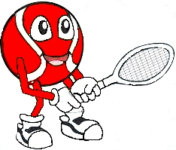
Try It Out Red Ball Tournaments
(includes multi-level competition for experienced players).

- First Saturday of each month
- Lynnwood Glen Tennis club (close to Menlyn).
- Report at 07:30am when children will be tested to determine their skill level.
- Coordination trainer available for beginners.
- Starts with short talk on fostering the love of tennis based on a scripture. (attendance not compulsory.)

- Ends at 10:00 am after a prize-giving where each child receives a merit prize based on their exhibited strengths.

R300 entry fee includes;
- racquets provided for 4 to 8-year-old children
- Small courts and racquets, lower nets & slower red balls

For details contact;
- Pierre: 078 451 4449
- Smetch: 063 821 2101
- Admin@GoodNewsTennis.co.za
Info@GoodNewsTennis.co.za

