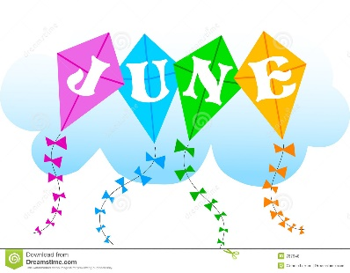
- Our focus for June was to increase the database of beginner players. We invited 30 players to participate in our fifth Red Ball Tournament held 1 June 2019. Of the 10 entries nine had played before.
- There were three entries who failed the co-ordination test and the coordination trainer let them play games with and without rackets.
- There were six children who did not own their own racket.
- Eight children do not have coaches and five were sufficiently co-ordinated to participate in the tournament.
- Medals: Marni Hugo – Vordering; Reinhardt Hugo – Positiewe gesindheid; Isabella de Kock – Positiewe gesindheid; Emma Pretorius – Unbeaten player; Keanan ? – Good Volley; Hendri Duplessis – belowende dien; Nusuku Gana – Good footwork; Tokano Moroko – Positive attitude; Melissa Mojoko – Sportsmanship award; Ava – Good forehand.
- Facebook advertisements are being investigated as an awareness and persuasion tool. Purchased the Udemy Facebook marketing internet course
- We need to brainstorm how to introduce Orange ball tournaments to GNTM offering.
- Presented GNTM Try-it-out red ball tennis tournaments mission, vision and strategy to Tuks Tennis (2 May) and MC Tennis (29 May). GNTM obtained promises of informal assistance from both tennis academies. In 2020 tournament calendar will be co-ordinated with MC Tennis red ball tournaments so that children can enter both tournaments over a period of a month.

