Chapter 2 Safin Families Holiday Tennis Tournament

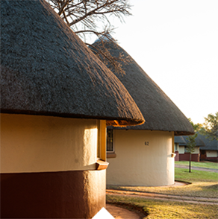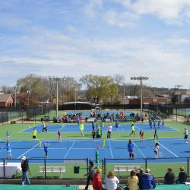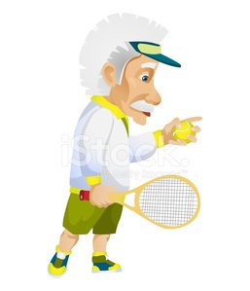
On the Easter weekend the greater large Safin family went to Buffelspoort holiday resort. Tammy’s grandmother booked the rondavels for the seven families to be next to each and near to the six tennis courts. Buffelspoort has a lot of attractions that the Safin family were going to enjoy together. Grandpa Rod had an entertainment program for the weekend.
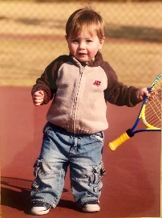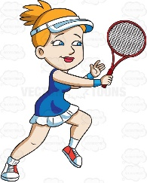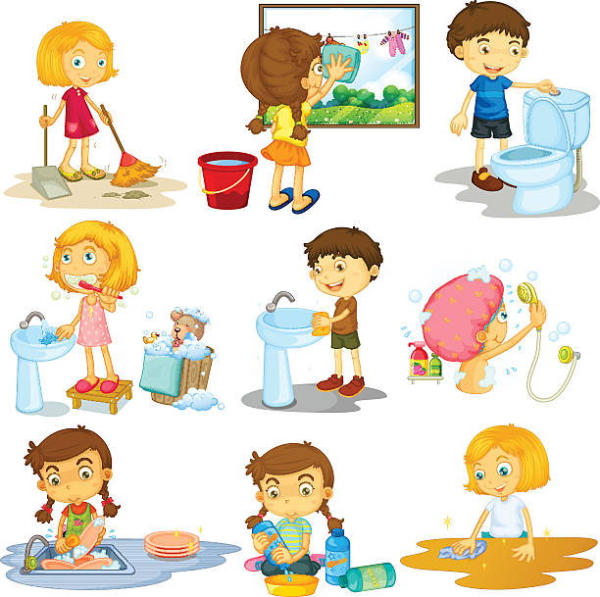
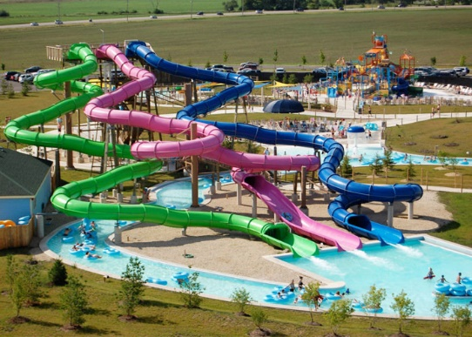
Tommy and his sister quickly did their chores and waited for the rest to go and swim. The adults headed for the heated pools while Tammy, Tommy and their many cousins raced for the super slides where lifesavers arranged turns to slide down the slide into the pool. All the children played on the super tubes until they closed.
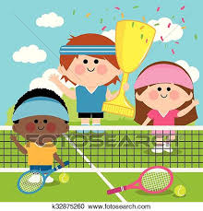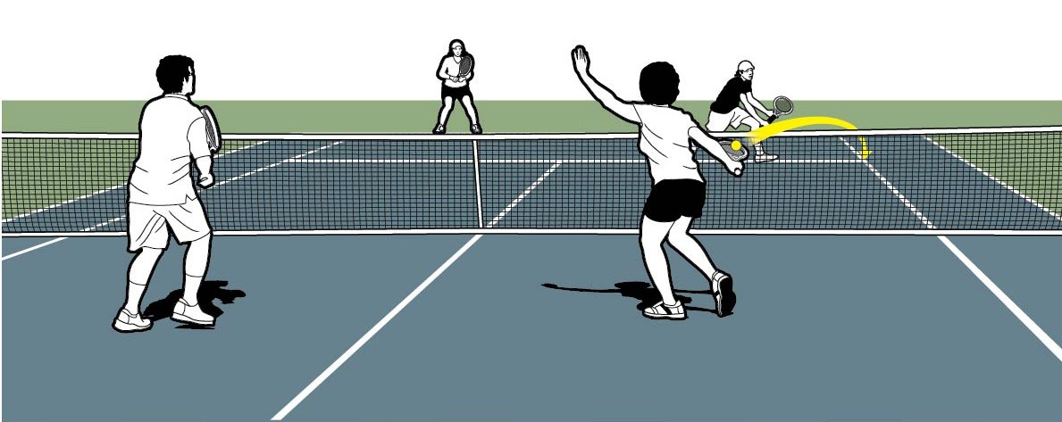
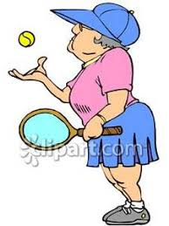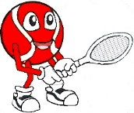

Around the campfire that night Grandpa Rod outlined the joint family events for the weekend. Tammy and her brother most looked forward to the family tennis championship. Grandpa Rod grouped the doubles teams with the eldest player partnering with the youngest player. This meant that the best seeded players were about the same age. The colour of the ball was dependent on the youngest players’ tennis ability. Tammy partnered with Grandpa Rod and Tommy partnered with Grandma Louise. Most of the family could play tennis and those who were beginners, landed in the red ball group. There was a lot of joking which pairing would win and why.
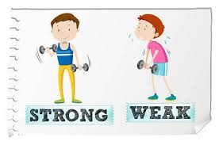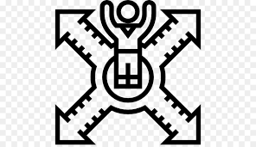
The family members had brought their own rackets and the resort supplied those who did not. There were three groups and the groups were decided by the weakest player. The largest group was the red ball group where Tommy and Tammy were with their cousins. Tammy’s cousins who never played tennis before were clumsy and fell over their own feet. Those cousins who played tennis anticipated where they would receive the ball and Tammy observed. They reacted quicker if drop shots were hit to them.
Grandpa Rod complimented Tammy on her balance when she moved to the ball and played a ball out of reach of their opponents. Grandma Louise remarked on Tommy’s hand eye co-ordination when he placed the ball into gaps on the court.
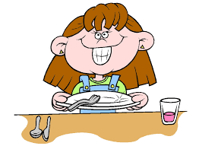
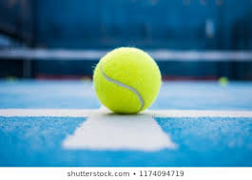
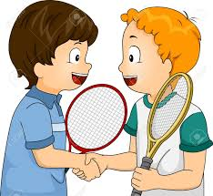
The red ball round robin matches lasted the whole morning. Tammy and Tommy were in the final after lunch because their fit and healthy grandparents dominated because they adapted to the wind. They were calm and taught Tammy and Tommy to adapt to the physical, emotional and mental stressors when they recovered between points and games. Both Grandpa Rod and Grandma Louise taught the Saffin ‘siblings’ good sportsmanship. They taught them when you are not sure of a call, the ball is in. They were friendly despite tense close matches that everyone wanted to win.
The pairs all had a tasty lunch in the restaurant close to the courts. When everyone had eaten the entire family came to watch the red ball final. Tammy realized that she and Grandpa Rod would have to have good court positioning throughout the match. Grandma Louise consistently hit shots to the open court with her ground shots and volleys.
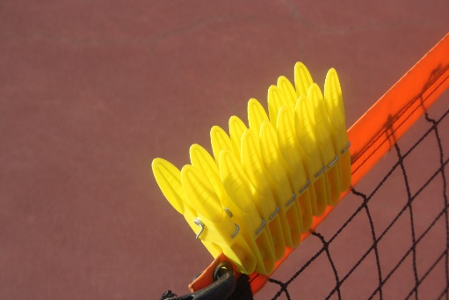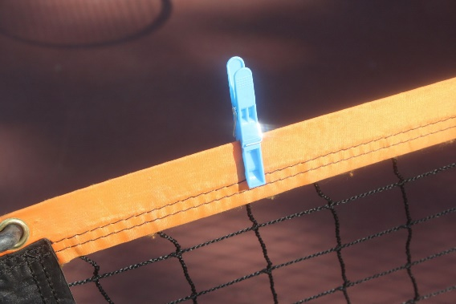

Both teams had ten pegs and each time they won a point they took a peg off the net. Tommy returned the balls hit to him but Grandma Louise was poaching at the net, so he only had a small area of the court. Grandpa Rod was hitting magnificent ground shots which tested Grandma Louise. With every point won the family crowd erupted in applause. Eventually both teams only had one peg left.
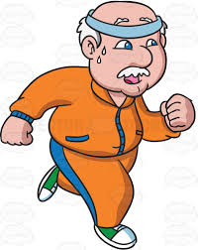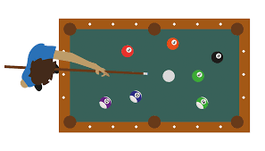

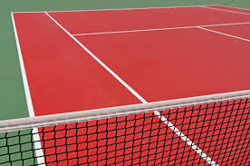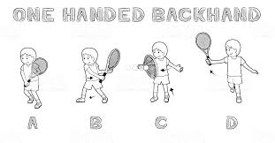
The grandparents were perspiring profusely as they fought to win the championships. The deciding point seemed to never end and the crowd was gasping as the difficult shots were retrieved. Tammy who was on the deuce side decided if she received a shallow short? ball on her forehand, she would hit down the tramline. Grandma Louise was shielding Tommy’s backhand by standing close to the centre of the court when Tammy was trying to hit to Tommy.
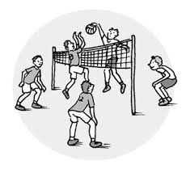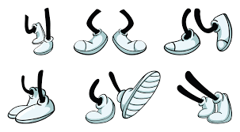
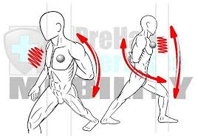
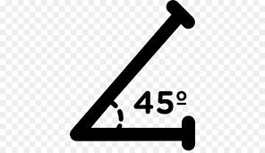
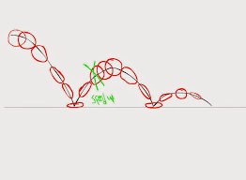
After a long and desperate rally Tammy received a short ball on her forehand. She moved her feet quickly, turned her shoulder and hit an unexpected shot down Grandma Louise’s tramline. Grandma Louise’s reflexes were good enough to get racket to the ball. The ball looped up to Tammy who was very close to the net. Not trusting her smash she hit a very soft but angled overhead in Tommy’s tramline. Tommy lunged forward in desperation, but the ball just bounced twice.
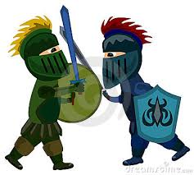
The crowd erupted in appreciation for a very hard-fought battle that either pair could have won.

