Why play tennis
There are many physical, social and psychological benefits of playing tennis, which in turn help to make it the “sport for a lifetime”.
PHYSICAL BENEFITS
- Burns fat, improves cardiovascular and immune system.
- Challenges balance and agility.
- Improves anticipation skills and reaction time.
- Hundreds of stops and starts, as many as five changes of direction per point. This builds leg strength and develops dynamic balance.
- Develops gross and fine motor control.
- Improves eye-hand co-ordination.
- Improves flexibility and mobility.

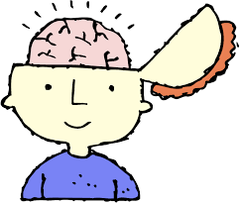
PSYCHOLOGICAL AND SOCIAL BENEFITS

- Requires that the player prepares to compete by practicing skills, checking equipment, and making line calls during a match. This helps children to learn how to accept responsibility.
- Adjusting to wind and sun challenges a child’s capacity to cope with and perform in the face of adversity.
- Adapting to the physical, emotional and mental stressors of a point develops coping mechanisms when recovering between points.
- Develops good sportsmanship, social skills and positive personality characteristics.
- Develops emotional control.
- Recreational tennis is fully adapted to the needs of the family (coloured ball tennis for children and ordinary ball tennis for adults).
SOME OTHER CRITERIA THAT NEED TO BE MENTIONED
- No sex bias – as both sexes can play on one court.
- Injury free – tennis has a low rate of injury.
- Individual participation – a player can hit against a wall or practice serving on their own.
- Inexpensive – as compared with other sports there are not many costs.
Source: ITF publication: Coaching Beginner and Intermediate Tennis Players (Chapter 1). Written by Miguel Crespo and Machar Reid.
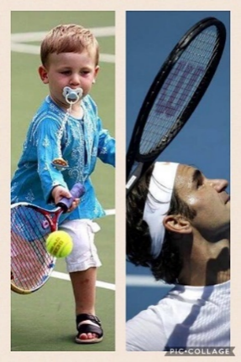
Notes for a story of a Pretoria toddlers’ journey until he becomes a champion.

